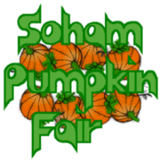Dear Supporter,

Thank you for showing an interest in Soham Pumpkin Fair and the possibility of running a stall.

The money we raise for our charities is always with the support of local organisations and businesses either through sponsoring prizes for the competitions on the day, by donating auction prizes, advertising in the brochure, or by hiring one of our market stalls. Last year, we were able to raise a record £5000 for our chosen beneficiaries:

St Andrew’s Church Restoration Appeal, Elysian Riding for the Disabled and Soham North Chapel Charitable Trust.

**Our chosen beneficiaries for this year are:**

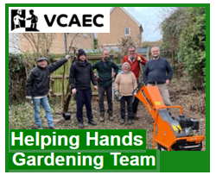****

&



**This year the Pumpkin Fair will take place on Saturday 27th September 2025 and our theme is ‘Michaelmas’.**

This Feast of Michael is always celebrated on the 29th of September - as it falls near the equinox, the day is associated with the beginning of autumn and the shortening of days. In England, it is one of the “quarter days”. It used to be said that harvest had to be completed by Michaelmas, almost like the marking of the end of the productive season and the beginning of the new cycle of farming. It was the time at which new servants were hired, or land was exchanged and debts were paid!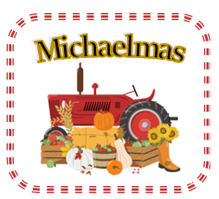

We would like our stall holders to join in with this idea and decorate their stall/gazebo with items appropriate to our theme – there will be a prize for the best!

**Our Stalls (Covered Market Stall, table size = 8ft x 4ft)**

**Cost: £25 per stall**.

Alternatively, if you want to bring your own gazebo, there are 2 pitch sizes we can offer you:

**3m x 3m pitch @ £50**

**OR 6m x 6m pitch @ £70**

Please complete the form below and return to the email address given together with a request for details of BACS payment. Alternatively, a paper copy of the form together with a cheque (made payable to ‘Soham Pumpkin Fair’) can be delivered to Michelle Harrison at the address given.

**A stall will not be reserved until we have received payment – you will then receive confirmation by e-mail or telephone.** (Please be aware that this may take a few days for us to acknowledge receipt).

Should we have to cancel the fair for any reason, your payment can be refunded, or you can choose to donate it to our beneficiaries. However, if **you** do not turn up on the day your payment will be non-returnable and will be taken as a donation.

Many thanks

Michelle Harrison (Chair & Stalls Manager)

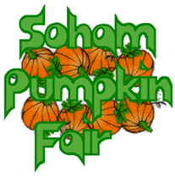

**Stalls Booking Form**

*(If you are planning to sell food, please contact the committee before submitting this form via the following email address:* *[stalls@sohampumpkinfair.co.uk](mailto:stalls@sohampumpkinfair.co.uk))*

**Stalls**

I/We would like to reserve: a stall 3m x 3m pitch 6 m x 6m pitch

(please put a cross in the appropriate box)

Payment will be for: £_____ (a stall @ £25, a 3mx 3m pitch @ £50 or a 6mx 6m pitch @ £70)

I/We are planning to ___________________________________________________

___________________________________________________

(Please indicate what will be done on the stall or in your gazebo)

**Contact Details:**

**Name: _ _ _ _ _ _ _ _ _ _ _ _ _ _ _ _ _ _ _ _ _ _ _ _ _ _ _ _ _ _ _ _ _ _ _**

**Organisation: _ _ _ _ _ _ _ _ _ _ _ _ _ _ _ _ _ _ _ _ _ _ _ _ _ _ _ _ _ _ _ _**

**Address: _ _ _ _ _ _ _ _ _ _ _ _ _ _ _ _ _ _ _ _ _ _ _ _ _ _ _ _ _ _ _ _ _ _ _**

**_ _ _ _ _ _ _ _ _ _ _ _ _ _ _ _ _ _ _ _ _ _ _ _ _ _ _ _ _ _ _ _ _ _ _ _ _ _ _ _**

**Telephone Number: _ _ _ _ _ _ _ _ _ _ _ _ _ _ _ _ _ _ _ _ _ _ _ _ _ _ _ _**

**Mobile Number: _ _ _ _ _ _ _ _ _ _ _ _ _ _ _ _ _ _ _ _ _ _ _ _ _ _ _ _**

**Email address: _ _ _ _ _ _ _ _ _ _ _ _ _ _ _ _ _ _ _ _ _ _ _ _ _ _ _ _**

*Please return your form to* [stalls*@sohampumpkinfair.co.uk*](mailto:stalls@sohampumpkinfair.co.uk)

***Preferred payment is paying by BACS*** *– please ask for details by emailing*

[*stalls@sohampumpkinfair.co.uk*](mailto:stalls@sohampumpkinfair.co.uk)

*Alternatively, your**cheque (made out to*

***Soham Pumpkin Fair****) and form can be returned to:*

**Michelle Harrison,**

**Soham Pumpkin Fair**

**10, Queensway**

**Soham, Cambs. CB7 5BX**