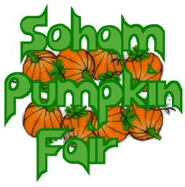Dear Supporter,

Thank you for showing an interest in Soham Pumpkin Fair.

The money we raise for our charities is always with the support of local organisations and businesses either through sponsoring prizes for the competitions on the day, by donating auction prizes, advertising in the brochure, or by hiring one of our market stalls. Last year, we were able to raise £5000 for our chosen beneficiaries: St Andrew’s Church Restoration Appeal, Elysian Riding for the Disabled and Soham North Chapel Charitable Trust.

Our chosen beneficiaries for this year are:



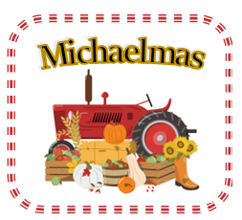

**This year the Pumpkin Fair will take place on Saturday 27th September 2025 and our theme is ‘Michaelmas’.**

This Feast of Michael is always celebrated on the 29th of September - as it falls near the equinox, the day is associated with the beginning of autumn and the shortening of days. In England, it is one of the “quarter days”. It used to be said that harvest had to be completed by Michaelmas, almost like the marking of the end of the productive season and the beginning of the new cycle of farming. It was the time at which new servants were hired, or land was exchanged, and debts were paid!

The brochure which contains information about our competitions, previous winners and beneficiaries together with *What’s On* at the fair. It is distributed electronically to every pupil in our Soham schools and made available on our Facebook page and website. Also, paper copies are distributed to local businesses, shops and libraries etc.

With all this in mind, I am writing to ask you to consider placing an advert in our brochure, or donating a prize for our auction, which enables us to raise more money on the day.

If you wish to place an advert, please complete the attached form by email and you can pay by BACS (alternatively return by post together with your cheque) Copy for your advert and payment need to be with us by 15th July 2025. For further information regarding placing an advert and auction donations contact me at [office@sohampumpkinfair.co.uk](mailto:office@sohampumpkinfair.co.uk)

We do hope you will be able to support this year’s Fair and if you decide to donate an auction prize as a small ‘thank you’, your organisation will be mentioned at the Fair.

You can find more details of our event on our website: [www.sohampumpkinfair.co.uk](http://www.sohampumpkinfair.co.uk)

Yours sincerely,

Jenny Fletcher (Secretary)

**If you would like to place an advertisement in the Pumpkin Fair Brochure, please tick the box for the size you want and return this form by email, along with *the artwork for your advert to:*** [***office@sohampumpkinfair.co.uk***](mailto:office@sohampumpkinfair.co.uk)

***Preferred payment is paying by BACS*** *– please ask for details by emailing*

[*office@sohampumpkinfair.co.uk*](mailto:office@sohampumpkinfair.co.uk)

**Full Page Ad (portrait) £110.00**

**Qtr Page Ad (portrait)** **£50.00**

**Half Page Ad (landscape) £70.00**

*Alternatively print and complete the form and post (together* with your cheque made payable to *Soham Pumpkin Fair*) for the agreed amount to:

**Please submit your artwork in one of the following formats:**

* **MS Word**
* **MS Publisher**
* **JPEG**
* **PDF**

**Michelle Harrison,**

**Soham Pumpkin Fair**

**10, Queensway**

**Soham, Cambs. CB7 5BX**

**Business Name ­­­­­­­­­­­­­­­­­­­­­­­­­­­­­­­­_____________________________________________________________________________**

**Phone Number/s ____________________________________________________________________________**

**Contact Name ______________________________________________________________________________**

**Address ___________________________________________________________________________________**

**__________________________________________________________________________________________**

**e-mail ____________________________________________________________________________________**

**Signature ________________________________________________________Date _____________________**